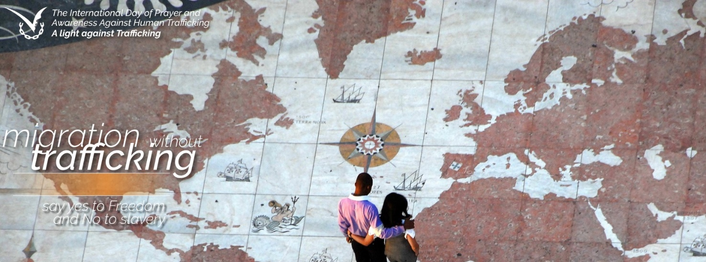

MIGRATION WITHOUT TRAFFICKING
say yes to Freedom
and no to slavery

The theme for the International Day of Prayer and Awareness against Trafficking in persons 2018 highlights the situation of human trafficking among people on the move: migrants, refugees and internal displaced people. We are invited to enkindle a light against human trafficking for these brothers and sisters of ours.
Trafficking in persons and migrants smuggling are different realities, though there are ever more interconnected. People on the move without regular travelling documents are threaten and exploited,andalso these are identified with human trafficking.
Their status makes them vulnerable to sexual and labour exploitation. Often migrants and refugees are forced to work many hours a day, with very little compensation. They accept such condition in order to pay the debt bounded for their trip. The debt may be increased by the trafficker, that revenge and threaten the migrants. Many of these victims disappear as victims of organ removals.
While migration flows are increasing in the globalized world, many countries develop restrictive migration policies. This situation favours vulnerability of people on the move, who are a group at high risk of being trafficked on the journey, in the transit courtiers, as well as at destination.
The International Day of Prayer and Awareness against Trafficking in Persons 2018 offers the opportunity to pray and to follow with our commitment the United Nation Global Migration Compact. Through it migration and refugee matters have become major issues in the international agenda, linked to recognition of the need for a comprehensive approach to human mobility, enhancing cooperation at the global level. Human trafficking is one of the central theme of the global migration compact.
Let us enkindle our hearts and lives, so as to be a welcoming light of hope and encounter.
Let us light a candle to warm our hearts and lives, so as to encounter and welcome our brothers and sisters on the move, building together hope and freedom from any kind of slavery.
​
preghieracontrotratta.org
preghieracontrolatratta
preghieratratta

