**Talitha Kum-UISG**

Piazza di Ponte S. Angelo, 28 - 00186 Roma

***Tel****. (39)06.68.400.235*  ***Fax*** *(39)06.68.400.239*

***E-mail:*** preghieracontrotratta@gmail.com

***Web****:*www.preghieracontrotratta.org



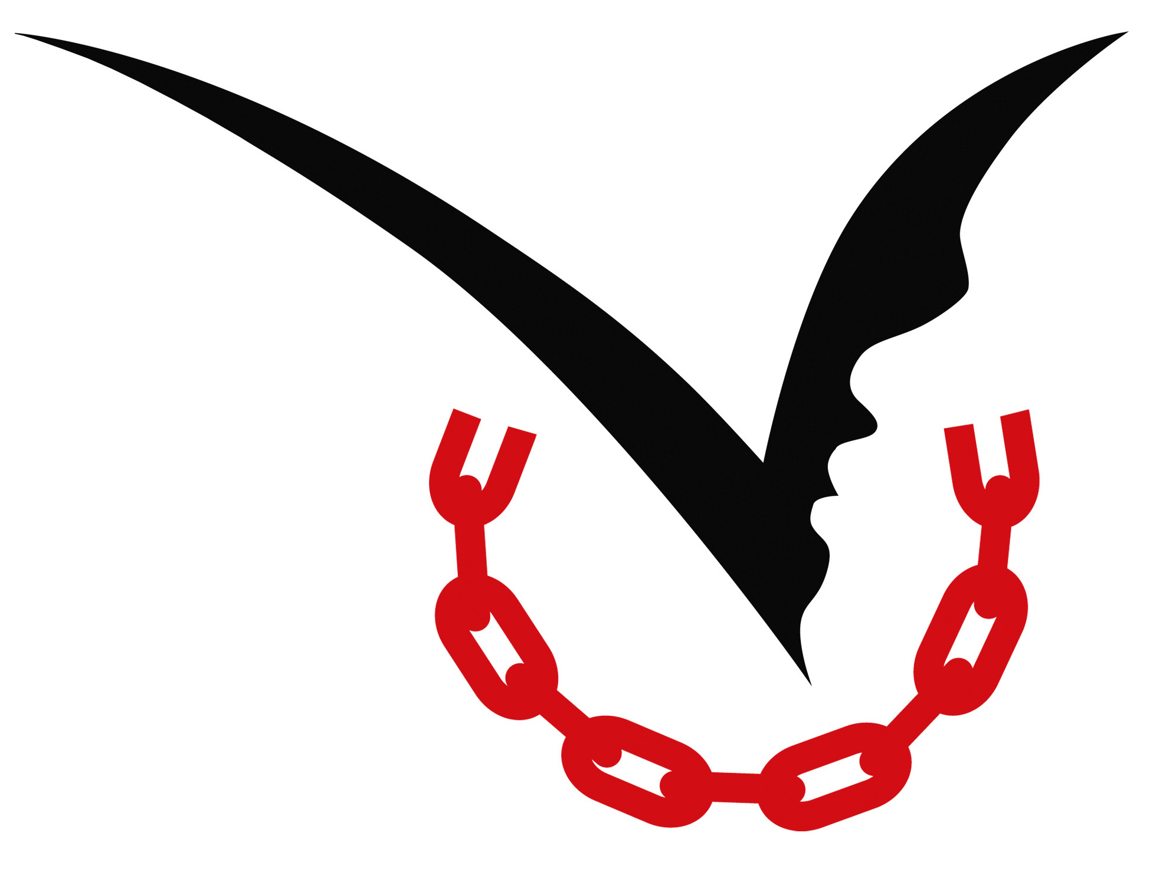

Press Release

**International Day of Prayer and Awareness against Human Trafficking**

**Journeying in Dignity: all continents united in prayer.**

**An international delegation of young people meet in Rome**

The ninth International Day of Prayer and Awareness against Trafficking in Persons will be held on **Wednesday February 8**, 2023.

The theme of this edition, chosen by an international group of youtimong people involved in the fight against trafficking, is *Journeying in Dignity*.

The steps, the journey, and the shared road between those who are committed to combatting trafficking and those who are victims and survivors. All of these are at the heart of this Day when we will witness thousands of people around the world - in many parishes, communities, groups - come together, reflect, pray and send a message to the world against this global phenomenon.

**WALKING IN DIGNITY: A WEEK OF INITIATIVES WITH YOUNG PEOPLE AT THE CENTRE**

This year, for the first time since its establishment - which took place in 2015 at the desire of Pope Francis - 15 young representatives of the partner organizations will gather in Rome from all continents for a week of meetings and training on trafficking in human beings. At the end of the week, the group will launch the statement of commitment which will start the process of preparation for the tenth anniversary of the Day (IDPAAHT).

**The week of gathering begins on Monday 6 February** with an **ecumenical vigil prayer** in English and Italian at 7.15 pm in the Parish of Santa Lucia, in the Prati district of Rome, an area of ​​the capital where three women in prostitution were brutally killed last November; the Catholic community will join the interfaith community.

The central moment of the week will be the online **Pilgrimage of prayer and awareness** on Wednesday, **February 8th**, the feast of Saint Bakhita, the universal symbol of the commitment of the Church against trafficking. The pilgrimage of prayer starts at 9.30 am CET time and, crossing the different time zones, will involve **all the continents** starting in Oceania, then Asia, the Middle East, Africa, Europe, Latin America, and closing at 16.30 in North America. The event will be live-streamed in 5 languages ​​(English, Spanish, Portuguese, French, Italian) on [www.prayagainsttrafficking.net](http://www.prayagainsttrafficking.net)

The **central block** is entrusted to young people committed against trafficking, and during which **a message from Pope Francis** will be aired, as has happened in previous years.

The participants in the online pilgrimage are the expression from **over 50 countries** on all continents. All people of goodwill; young and old, women and men, lay and religious people, survivors, and activists are united against trafficking.

**THE FLASH-MOB AND THE END OF THE WEEK IN ST. PETER'S SQUARE**

**On February 10, Friday at 15.30** in via della Conciliazione, the dance group "*Evolution Company of the Holy Dance*" together with the group of young international representatives will give life through a **flash-mob against trafficking**.

The week ends on **Sunday 12 February** with participation in **the Angelus Prayer** in St. Peter's Square.

The initiative is coordinated by **Talitha Kum**, the international anti-trafficking network of more than 6,000 nuns, friends and partners, and is promoted by **the International Union of Superiors General** (UISG) and **the Union of Superiors General** in partnership with the **Dicastery for Promoting the Integral Human Development**, the **Dicastery of Communication**, the **Pope's Worldwide Prayer Network**, **Caritas Internationalis**, **CoatNet**, the **Focolare Movement**, the **Jesuit Refugee Service**, the **World Union of Catholic Women's Organizations** (WUCWO), The **Clewer Initiative**, the **Pope John XXIII Community Association**, the  **International Forum of Catholic Action Associations** and **Federations of Movements**, **the Association of Italian Catholic Guides and Scouts** (Agesci), the **Santa Marta Group** and many other organizations around the world. The Day was made possible thanks to the support of the **Global Solidarity Fund**.

“*The theme chosen this year "* ***Journeying in dignity*** *" is an invitation to all people of good will to walk with the victims and survivors of human trafficking, and in particular the migrant populations, as pilgrims of human dignity and hope. Young people, adults and children, people of different religious traditions, cultures and generations. Only together, as a community, we can put an end to this scourge. Safeguarding the dignity of every person is only possible if we know how to upholdpeace and protect the environment* - Sister **Abby Avelino**, MM, coordinator of the day, said.

**The DAY ON TWITTER**

The organizers invite you to dedicate a tweet on February 8 using the official hashtag #PrayAgainstTrafficking

**For press contacts**

Alessandra Tarquini +393479117177 [feb8@talithakum.info](mailto:feb8@talithakum.info)

[www.prayagainsttrafficking.net](http://www.prayagainsttrafficking.net)